Digital Signal Processing
Year : 2016-17 Div : B.E. A,B,C
Lecture – 06

- Enlist different classes of signals with example for each class.
- How periodicity is calculated in Analog and discrete domain?
- Classify x[n] = exp(-n) . sin(2n)
  - Linearity
  - Periodicity
  - Even/Odd
  - Deterministic/ Random
- Find even and odd parts of following signal
x[n] = 0.5 + cos²(n)

Q1.)Signals are classified into the following categories:
- Continuous Time and Discrete Time Signals
- Deterministic and Non-deterministic Signals
- Even and Odd Signals
- Periodic and Aperiodic Signals
- Energy and Power Signals
- Real and Imaginary Signals

Continuous Time and Discrete Time Signals
A signal is said to be continuous when it is defined for all instants of time.
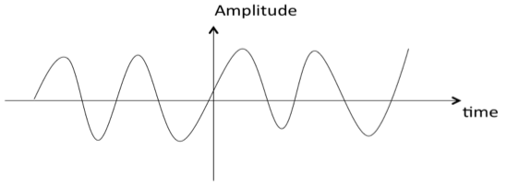
A signal is said to be discrete when it is defined at only discrete instants of time/
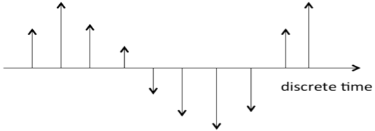

Deterministic and Non-deterministic Signals
A signal is said to be deterministic if there is no uncertainty with respect to its value at any instant of time. Or, signals which can be defined exactly by a mathematical formula are known as deterministic signals.
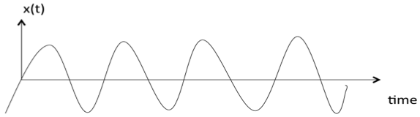
A signal is said to be non-deterministic if there is uncertainty with respect to its value at some instant of time. Non-deterministic signals are random in nature hence they are called random signals. Random signals cannot be described by a mathematical equation. They are modelled in probabilistic terms.
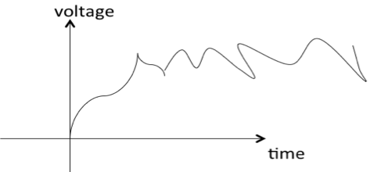

Even and Odd Signals
A signal is said to be even when it satisfies the condition x(t) = x(-t)
Example 1: t2, t4… cost etc.
Let x(t) = t2
x(-t) = (-t)2 = t2 = x(t)
∴,∴, t2 is even function
Example 2: As shown in the following diagram, rectangle function x(t) = x(-t) so it is also even function.
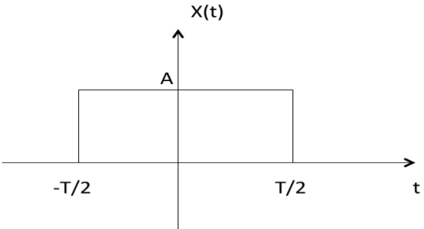
A signal is said to be odd when it satisfies the condition x(t) = -x(-t)
Example: t, t3 ... And sin t
Let x(t) = sin t
x(-t) = sin(-t) = -sin t = -x(t)
∴,∴, sin t is odd function.
Any function ƒ(t) can be expressed as the sum of its even function ƒ_{e}(t) and odd function ƒ_{o}(t).
ƒ(t ) = ƒ_{e}(t ) + ƒ₀(t )
where
ƒ_{e}(t ) = ½[ƒ(t ) +ƒ(-t )]

Periodic and Aperiodic Signals
A signal is said to be periodic if it satisfies the condition x(t) = x(t + T) or x(n) = x(n + N).
Where
T = fundamental time period,
1/T = f = fundamental frequency.
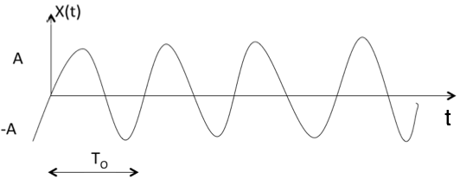
The above signal will repeat for every time interval T₀ hence it is periodic with period T₀.

Energy and Power Signals
A signal is said to be energy signal when it has finite energy.
EnergyE=∫∞−∞x2(t)dtEnergyE=∫−∞∞x2(t)dt
A signal is said to be power signal when it has finite power.
PowerP=limT→∞12T∫T−Tx2(t)dtPowerP=limT→∞12T∫−TTx2(t)dt
NOTE:A signal cannot be both, energy and power simultaneously. Also, a signal may be neither energy nor power signal.
Power of energy signal = 0
Energy of power signal = ∞

Real and Imaginary Signals
A signal is said to be real when it satisfies the condition x(t) = x*(t)
A signal is said to be odd when it satisfies the condition x(t) = -x*(t)
Example:
If x(t)= 3 then x*(t)=3*=3 here x(t) is a real signal.
If x(t)= 3j then x*(t)=3j* = -3j = -x(t) hence x(t) is a odd signal.
Note: For a real signal, imaginary part should be zero. Similarly for an imaginary signal, real part should be zero.

